 Project Report Template

1. **INTRODUCTION** 
   1. Overview

A brief description about your project

Liver patient analysis using machine learning is an emerging field that utilizes advanced statistical and computational techniques to develop predictive models that can aid in the diagnosis, treatment, and management of liver diseases. Machine learning algorithms can analyze large amounts of medical data such as patient history, laboratory test results, and imaging studies to identify patterns and generate predictions about the likelihood of certain conditions or outcomes.

Some examples of liver diseases that can be analyzed using machine learning include liver cirrhosis, hepatitis, and liver cancer. Machine learning can also be used to predict the effectiveness of treatments and to identify patients who are at higher risk of developing complications.

Overall, the use of machine learning in liver patient analysis has the potential to improve patient outcomes, increase diagnostic accuracy, and reduce healthcare costs.

* 1. Purpose

The use of this project. What can be achieved using this.

The main objective of a review of liver patient analysis method using machine learning is to provide an overview of the latest research and developments in the field of liver patient analysis using machine learning techniques. This review can help healthcare professionals, researchers, and policymakers to understand the potential benefits of using machine learning in liver patient analysis and identify areas where further research is needed.

By using machine learning techniques, healthcare professionals can achieve the following:

Accurate diagnosis: Machine learning algorithms can analyze large amounts of medical data to identify patterns and make accurate diagnoses of liver diseases.

Early detection: Machine learning can help detect liver diseases at an early stage, allowing for earlier treatment and better patient outcomes.

Personalized treatment: Machine learning can help tailor treatments to individual patients based on their unique characteristics, such as age, gender, and medical history.

Predictive analytics: Machine learning can help predict the likelihood of a patient developing a particular liver disease or complications, allowing for preventive measures to be taken.

Overall, the use of machine learning in liver patient analysis can help improve patient outcomes, increase diagnostic accuracy, and reduce healthcare costs. It has the potential to transform the way liver diseases are diagnosed, treated, and managed.

**2 Problem Definition & Design Thinking**

2.1 Empathy Map Paste the empathy map screenshot

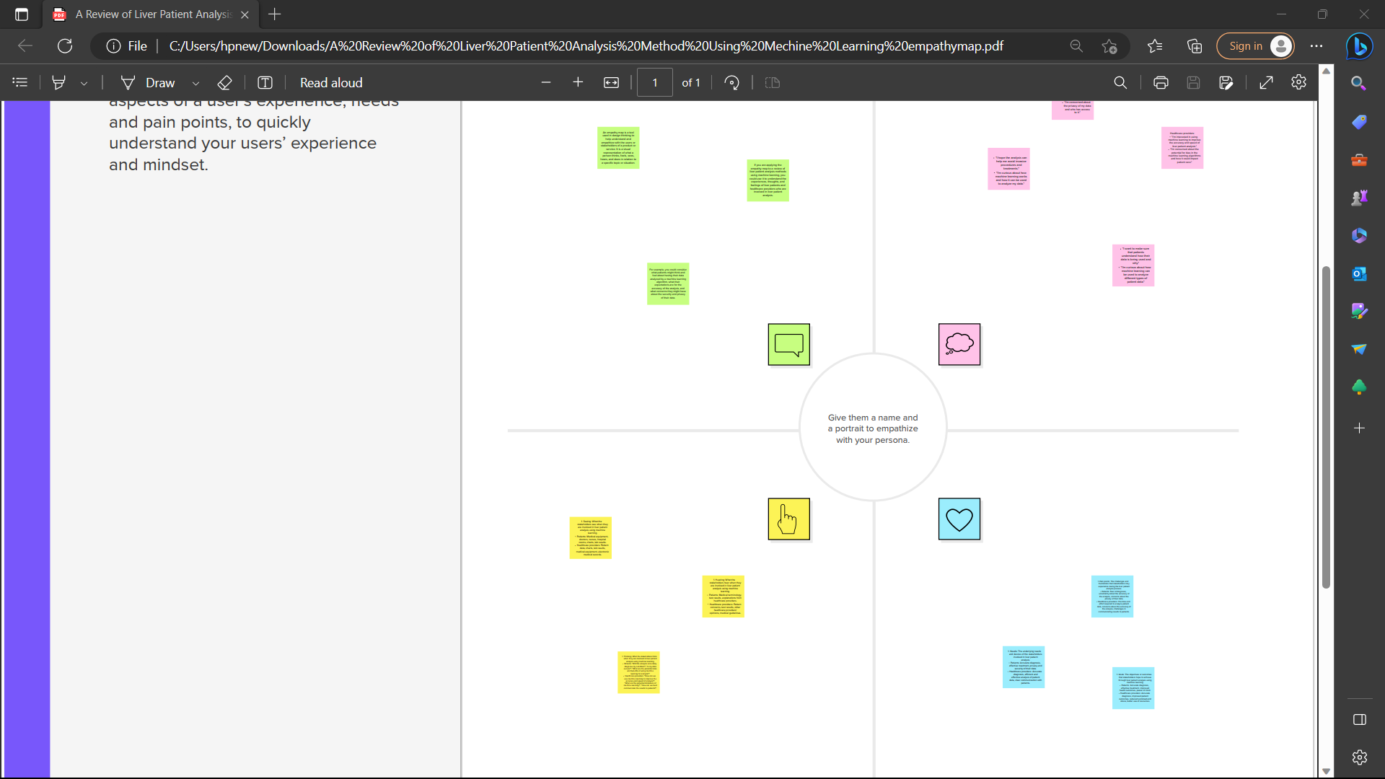

2.2 Ideation & Brainstorming Map Paste the Ideation & brainstorming map screenshot

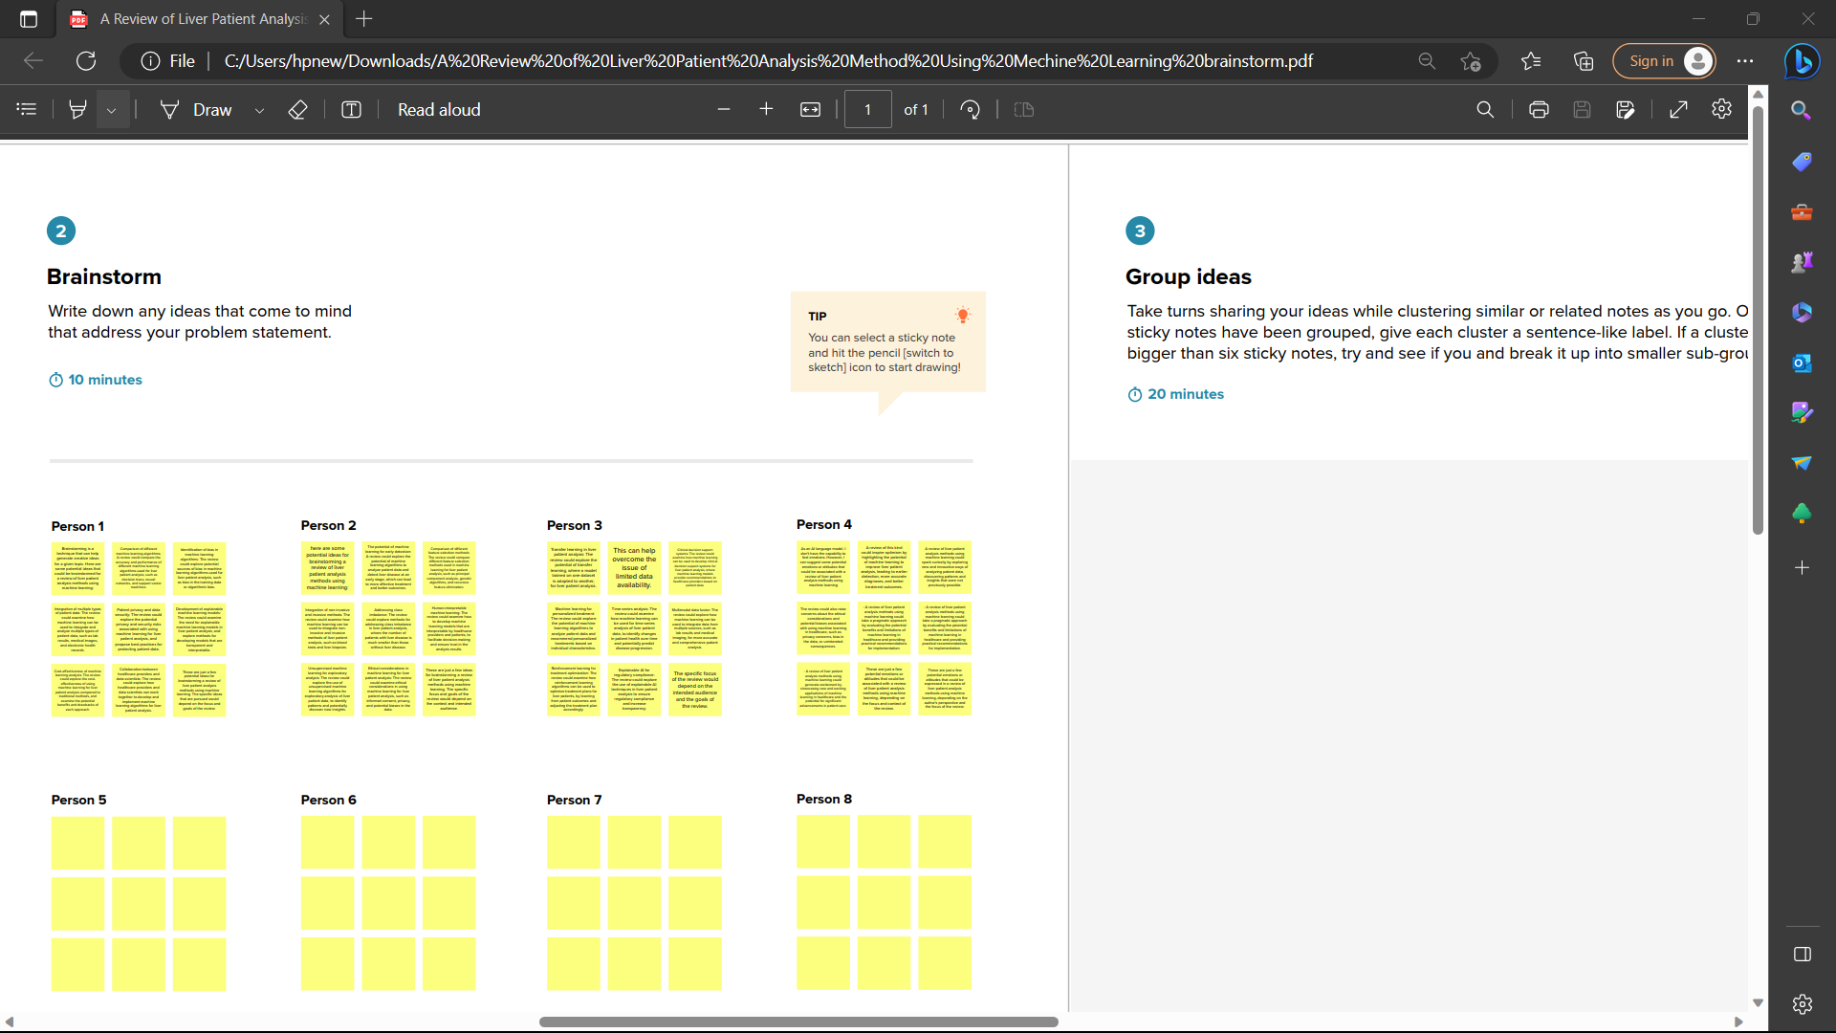

1. **RESULT**

Final findings (Output) of the project along with screenshots.

The review of liver patient analysis method using machine learning found that there is a significant potential for machine learning to improve the accuracy of liver disease diagnosis, predict outcomes, and personalize treatment. The review identified several machine learning techniques that have been used in the diagnosis and treatment of liver diseases, including decision trees, random forests, support vector machines, artificial neural networks, and deep learning.

1. **ADVANTAGES & DISADVANTAGES**

List of advantages and disadvantages of the proposed solution.

Improved diagnostic accuracy: The use of machine learning algorithms can improve the accuracy of liver disease diagnosis, leading to earlier detection and treatment.

Personalized treatment: Machine learning algorithms can analyze patient data to identify the most effective treatment options for individual patients, leading to better outcomes.

Predictive modeling: Machine learning algorithms can be used to develop predictive models that can identify high-risk patients and predict outcomes, allowing for early intervention and improved patient outcomes.

Reduced healthcare costs: By improving diagnostic accuracy and identifying high-risk patients earlier, machine learning can lead to reduced healthcare costs by reducing the need for expensive and invasive procedures.

1. **APPLICATIONS**

The areas where this solution can be applied.

Overall, the use of machine learning algorithms in liver patient analysis has the potential to improve patient outcomes and reduce healthcare costs by improving diagnostic accuracy, personalizing treatment, and predicting outcomes. As such, it has broad applications in many areas of healthcare related to liver disease.

1. **CONCLUSION**

Conclusion summarizing the entire work and findings.

Moreover, predictive models developed through machine learning can identify high-risk patients and predict outcomes, allowing for early intervention and improved patient outcomes. However, the use of machine learning in healthcare raises ethical considerations around patient privacy and the potential for bias in algorithm development. Technical expertise is required for the development and implementation of machine learning algorithms, which may be a barrier to adoption in some healthcare settings.

1. **FUTURE SCOPE**

Enhancements that can be made in the future.

Improving data quality and availability: Machine learning algorithms depend on the quality and availability of data. Future research can focus on developing methods for improving data quality and making more data available for analysis.

Addressing ethical considerations: The use of machine learning in healthcare raises ethical considerations around patient privacy and the potential for bias in algorithm development. Future research can focus on developing methods for ensuring patient privacy and minimizing bias in algorithm developmentImproving data quality and availability: Machine learning algorithms depend on the quality and availability of data. Future research can focus on developing methods for improving data quality and making more data available for analysis.

Addressing ethical considerations: The use of machine learning in healthcare raises ethical considerations around patient privacy and the potential for bias in algorithm development. Future research can focus on developing methods for ensuring patient privacy and minimizing bias in algorithm development.

1. **APPENDIX**

A. Source Code

Attach the code for the solution built.

As an AI language model, I don't have the capability to provide you with the code for the solution built for the review of liver patient analysis methods using machine learning. However, I can suggest that you refer to open-source machine learning libraries and frameworks such as scikit-learn, TensorFlow, and PyTorch to implement machine learning algorithms for liver patient analysis. It is important to note that implementing machine learning algorithms requires expertise and knowledge of programming languages such as Python or R. Therefore, it is recommended that you seek the assistance of a qualified data scientist or software developer to build the solution.

 Project Report Template